JDBC
- JDBC是链接Java应用和数据库的API
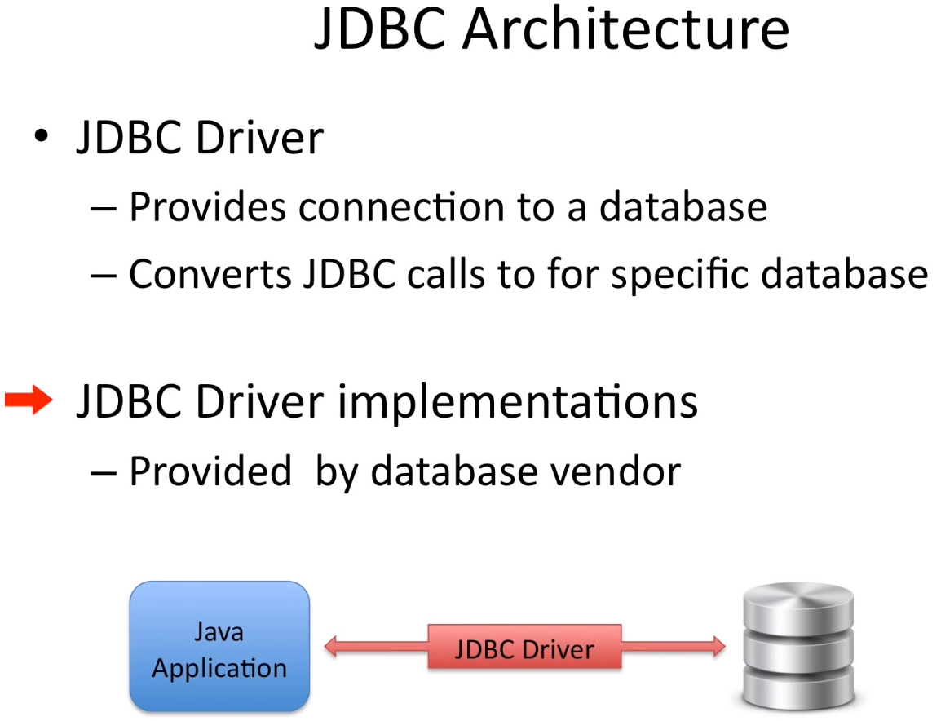
-JDBC运作流程
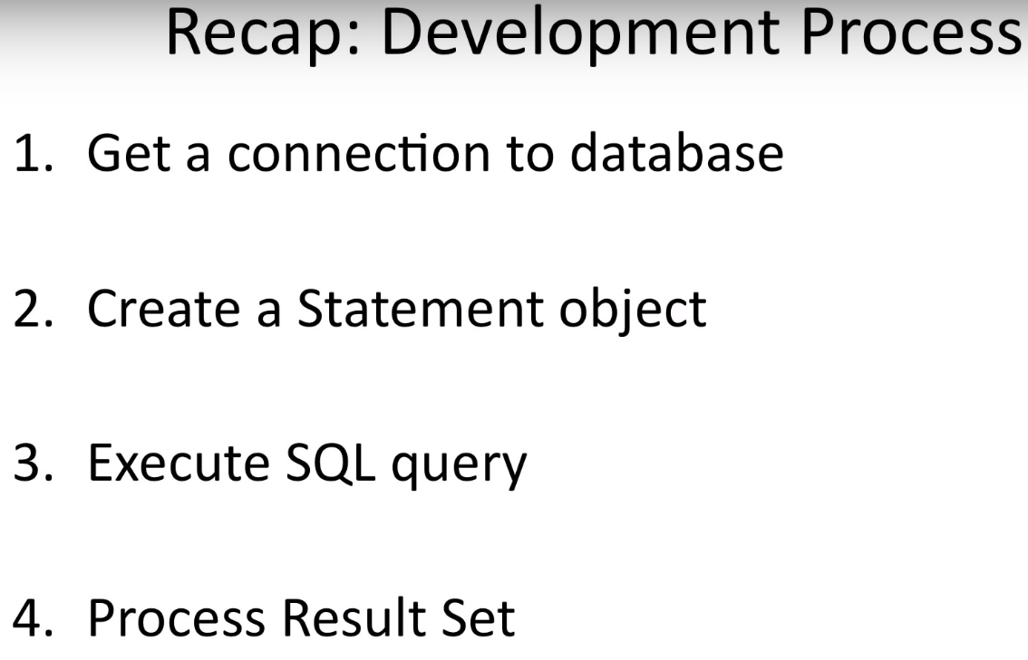

C:\Program Files\MySQL\MySQL Server 5.6\bin

- 卡在了eclipse和mysql配置的问题？
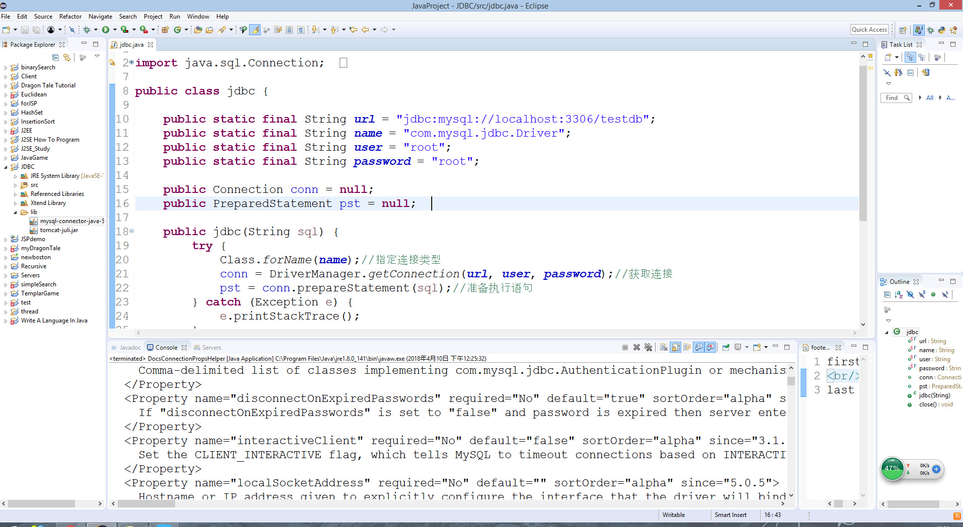
https://www.youtube.com/watch?v=2i4t-SL1VsU&index=2&list=PLEAQNNR8IlB4R7NfqBY1frapYo97L6fOQ

